Question 13:

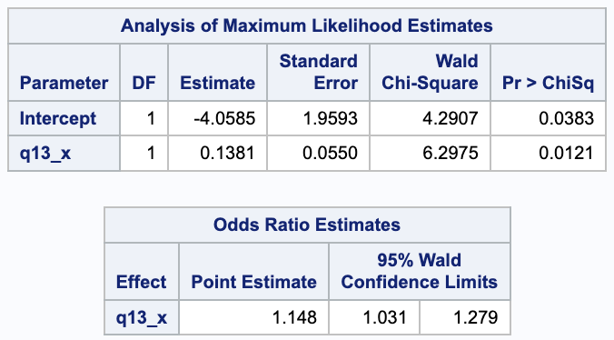

For every one change in getting all of the other questions correct, the likelihood that the student got question 13 correct increases by e0.1381. Because the p-value for this parameter estimate is less than 0.05, this relationship is significant. Looking at the odds ratio, the odds of getting question 13 correct is 1.148 times the odds of getting question 13 wrong as the number of all other correct questions increases. This is also significant because 1 is not included in the interval.

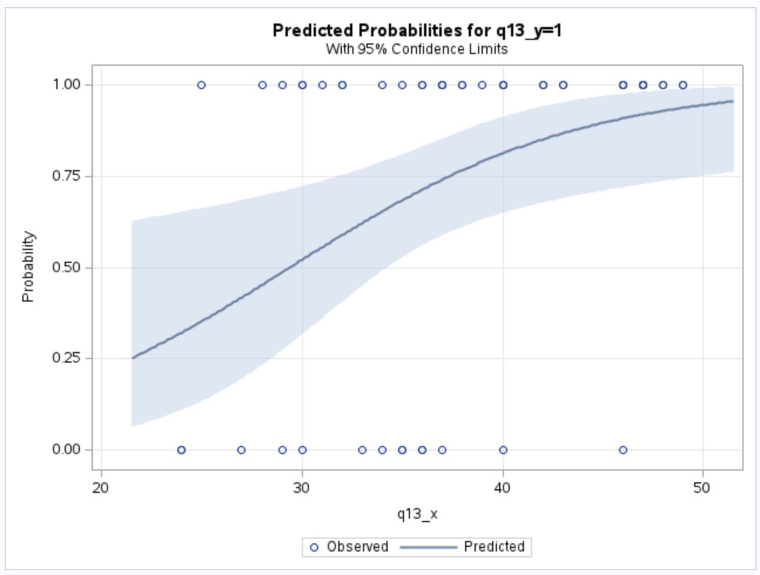

Looking at the plot of this regression, students did not disproportionately get this question right over those who got fewer of the other questions correct. Thus, students who got more of the other questions correct, as well as students who did not get as many of the other questions correct, both got question 13 wrong. However, more people who got more of the other questions right got question 13 correct more often. Because of this, I believe the question should be removed from the quiz.

Question 22:

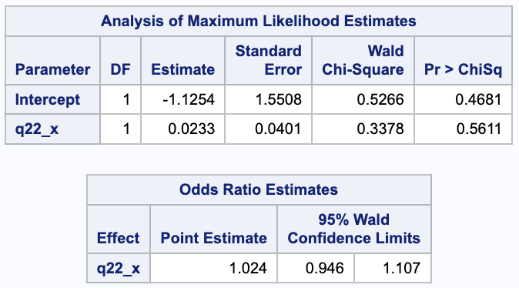

For every one change in getting all of the other questions correct, the likelihood that the student got question 22 correct increases by e0.0233. Because the p-value for this parameter estimate is greater than 0.05, this relationship is not significant. Looking at the odds ratio, the odds of getting question 22 correct is 1.024 times the odds of getting question 22 wrong as the number of all other correct questions increases. This is not significant because 1 is included in the interval.

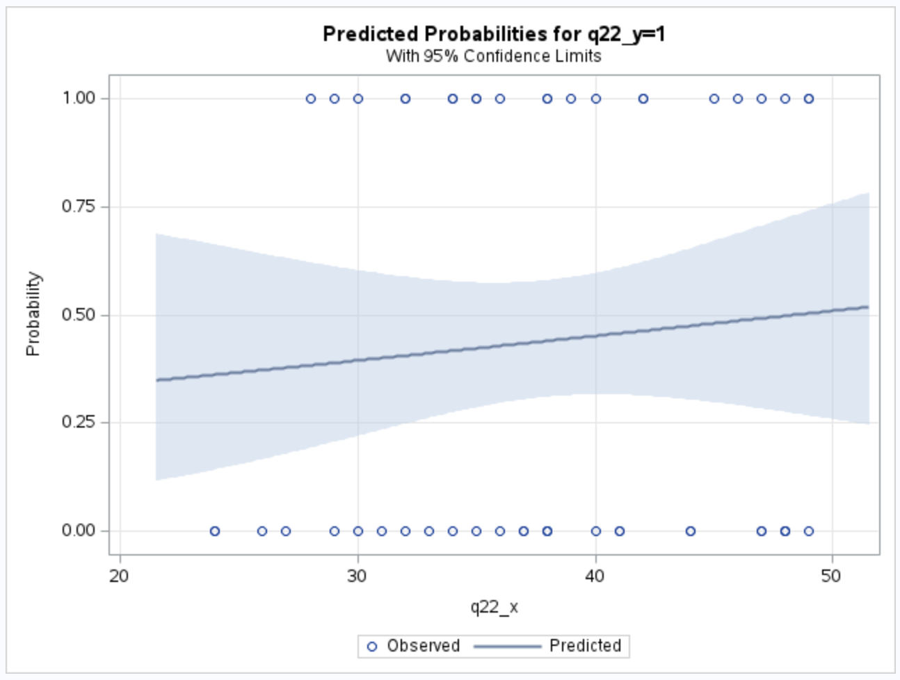

Looking at the distribution of the regression, the distribution of overall answers correlated to question 22 was fairly even. The students getting fewer questions right in total were likely to get question 22 wrong as well. Students who got more of the other questions right were more likely to get question 22 right. Therefore, I cannot make any judgment on the question.

Question 41:

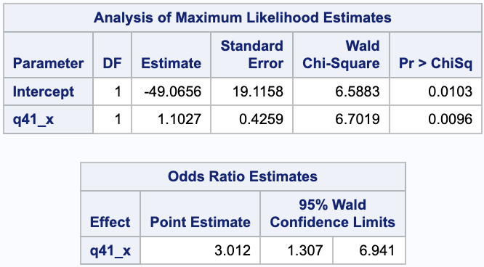

For every one change in getting all of the other questions correct, the likelihood that the student got question 41 correct increases by e1.1027. Because the p-value for this parameter estimate is less than 0.05, this relationship is significant. Looking at the odds ratio, the odds of getting question 41 correct is 3.012 times the odds of getting question 41 wrong as the number of all other correct questions increases. This is significant because 1 is not included in the interval.

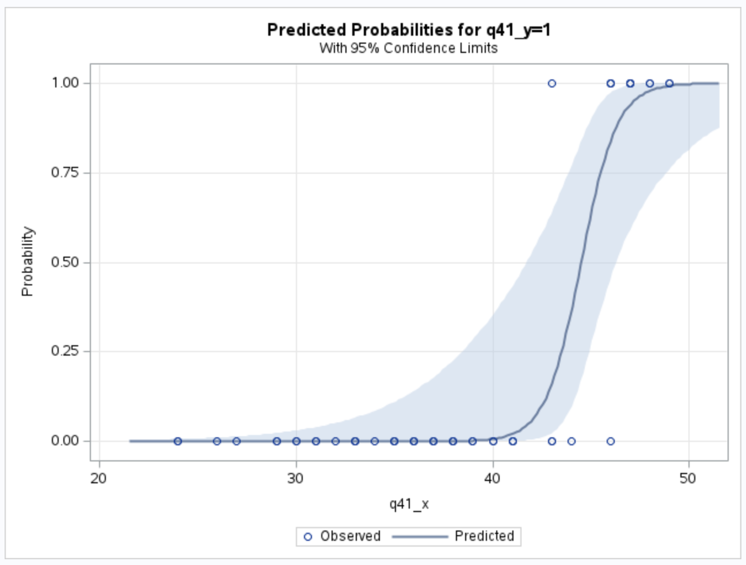

Students who got a fewer total number of correct questions got question 41 wrong more often than students who had a higher total number of correct questions. This would indicate that the question is more difficult than intended so more students got it wrong if only people who are getting most of the questions right are getting question 41 right. Because of this, I believe the question should be removed from the quiz.